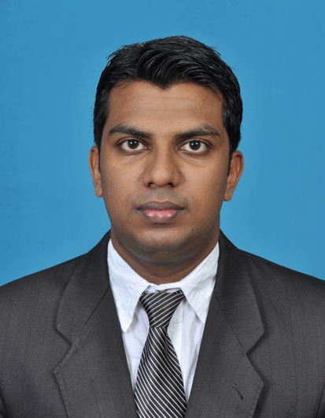
CURRICULUM VITAE
ZIYAN AHAMED
No.07,Second Lane, Mahabage, Ragama
Sri Lankan
Tel: 94 778377377 / 94 552288309
E-mail: ziyanahamed@yahoo.com

Job Objectives and Career Goals

Job Objectives

To effectively utilize the knowledge and skills acquired from both academic and work experience in order to achieve professional excellence while being a valuable team member in a challenging environment of accounting and administration management.

Personal Profile

I am a highly self-motivated individual with a high level of reliability and commitment to work, capable of enduring hardships and working under pressurized situations. I have developed strong analytical & interpersonal skills during my intensive working experience as an Executive.

Working Experience

Approximately 1.5 years working experience as Senior Executive in Star Manzil (April 2013 To August 2014)
- Prepare itineraries
- Prepare agendas
- Expense reports
- Also knowledgably about Organize and maintain file and records & administrative activities

Approximately 5 years working Experience as an Senior Executive Accounts & Administration in Authorised (Business Partner Dialog) Cell World (PVT) Ltd (2008 To 2013)

- Working in the capacity of Senior Executive, my responsibilities and duties were extended around the following areas,

- Payment handling and good knowledge on stocks managing.
- Competent numeric skills and good communication skills
- Able to work quickly and accurately
- Customer Relations and Enjoy working with customers
- Willingness to work individually or in a team environment
- Prepare monthly commission reports and ability to meet deadlines.
- Can be depended on to follow task through to completion
- Capability of using computer accounting package such as Pay-roll system, Quick book & Tally.
- Experience as a Showroom in charge officer.
- Experience on handling 3 Franchise outlets managed by Dialog Company.
- Handling of sales inquires on mobile phones.
- Good experience on preparing credit card statements
- Experience on handling documentation work

Professional Qualifications

- Completed the Graduate Diploma in Business Management at London Business School, Bambalapitiya Sri Lanka (2009 To 2011) Wigan & Leigh College United Kingdom.
- Completed the Advance Diploma in Business Management at London Business School, Bambalapitiya Sri Lanka Wigan & Leigh College United Kingdom.
- Completed the Diploma in Modern Management at London Business School, Bambalapitiya Sri Lanka (2011) Wigan & Leigh College United Kingdom
- Completed the Diploma in Financial Management at London Business School, Bambalapitiya Sri Lanka (2009) Wigan & leigh College United Kingdom
- Completed the Foundation Level of The Institute of Chartered Accountants of Sri Lanka.
- Completed the Diploma in Computer Accounting at British Informatics of Computer Technology, Wellawatta. (2008)
- Certificate in Computer Programming (Basic level) Technical Engineering College (Sri Lanka)
- Completed the Pre-Intermediate 1 To 3 (CMBPL1-WFL1) English Language Course at British council (2012)
- Completed the N.C.E. (National Certificate) in English to Commerce Industry & Further Education (2007/2008) & Technical College Badulla.

Academic Qualification

- General Certificate of Education (Advanced Level) 2007

Subject | Grade | Subject | Grade
Business Studies | C | Accountancy | C
Economics | C | Common General Test Marks | 060

- General Certificate of Education (Ordinary Level) 2004 -Uva College Badulla

Subject | Grade |  | Subject | Grade
Health Science | A |  | Science | C
English | C |  | Mathematics | C
Social Studies | C |  | Commerce | C
Sinhala | C |  | Arts | S
Islam | C |  | Literature | S

Computer Literacy
- Ms Word | - MYOB Accounting Software
- Ms Excel | - Payroll
- Ms Power point | - Quick book
- Internet & e-mail | - Tally
- Photo Editing | - Acc Pac

Language Competency

 | Reading | Writing | Speaking
English | Good | Good | Good
Sinhala | Excellent | Excellent | Excellent
Tamil | Non | Non | Excellent
Hindi | Non | Non | Good

Personal Details
Name in Full : Abdul Malik Ziyan Ahamed
Age : 27 Years
Gender : Male
Marital Status : Single
Height : 5”11
Nationality : Sri Lankan
School Attended : Dharmadutha National College Badulla
Current Address : No.07,Second Lane, Mahabage, Ragama
Permanent Address : 39/B Lower Street Badulla
Contact No. : 94778377377 / 94552288309
E-Mail : ziyanahamed@yahoo.com

Non Related Referees

Mrs Iresha Yasanayake (LL.B.Colombo)  Attorney at Law,Notary Public  Commissioner for Oaths,Badulla  Email: ireupamali@yahoo.com  Mobile: 94 776128757 | Mrs Vindhya Gunaratna  Internal Audit Executive  Lanka Bell (Ltd)  Mobile: 94 772967599  Tel : 94 115668152
I certify that the above information is true and correct. Also, I am aware that misrepresentation of information, providing of false information, or willful suppression of any material fact will result for my application to be rejected and, if found subsequently to the appointment, I will be dismissed without any compensation.

Ziyan
Signature Date

